3GPP TSG RAN WG1 Meeting #83 R1-156687
Anaheim, USA, 15th – 22th November 2015

Source: Intel Corporation
Title: Discussion on baseline sidelink performance for V2V communication
Agenda item: 6.2.8.1.1
Document for: Discussion and Decision

Introduction
At the TSG RAN1 Meeting #82, the evaluation assumptions for feasibility study on LTE based V2X services [1] were agreed and captured in [2]. In this contribution, we discuss possible baseline settings for V2V performance analysis providing evaluation results based on Rel.12 sidelink design. In our view, it is important to show incremental gains that can be achieved by applying certain techniques to improve V2V performance and possibly identify bottlenecks. Therefore, the presented analysis serves as a Rel.12 sidelink performance reference for the comparison with enhanced design options. In addition, we provide the reference Rel.12 resource configuration settings in order to simplify the comparative analysis of different design enhancements in terms of resource allocation.
Our views on other aspects of V2V/V2X communication and enhanced design options are presented in companion contributions [5]-[12].

On Factors Impacting V2V Performance
There are many factors that can have significant impact on V2V performance characteristics which may complicate comparative analysis of different design enhancements. In particular, resource allocation (amount of resources and granularity) as well as MCS selection and target link budget may have significant impact on V2V performance. For fair comparative analysis with LTE Rel.12 design, it makes sense to have a common understanding on baseline/reference resource configuration and common assumptions on at least resource allocation size and MCS levels.
For Rel.12 sidelink air-interface, the overall performance should be separately analyzed for PSCCH and PSSCH channels in order to determine the limiting channel in each deployment scenario. It is also important to discuss and agree on resource granularity for the Rel.12 sidelink design and use similar settings to analyze potential gains of the enhanced design options, given that performance improvement may come from different factors.

Resource Pool Configuration
In our view, the single PSCCH/PSSCH pool with 40ms periodicity and 8 subframes allocated for PSCCH and 32 subframes for PSSCH may be a good reference configuration for V2V system level study. In addition, the 10MHz spectrum with 50PRBs can be assumed for analysis as it is already defined in V2V evaluation methodology [2].
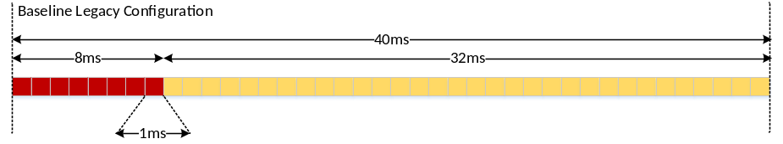
Figure 1: Baseline configuration for sidelink V2V evaluation.
Observation 1
- The 40 ms SCI period with 8 SFs allocated for PSCCH and remaining 32 subframes used for PSSCH can be considered as a default (baseline) option for Rel.12 sidelink evaluation.

Link Budget Considerations
In this section, we analyze PRR for PSCCH and PSSCH channels in interference free environment (i.e. w/o taking into account IBE, co-channel interference and half-duplex effects. The PRR analysis is shown in Figure 2 and can be used as an indication of potential link budget constraints in considered scenarios for the selected target ranges of 320m (Freeway) and 150m (Urban).
For PRR analysis in interference free environment, we used the following transmission parameters (please refer for more details to Appendix):
- PSCCH: 1 PRB, 2 TTIs, SCI Format 0;
- PSSCH:
  - for 190 bytes - 12 PRBs, 4 TTIs, QPSK;
  - for 300 bytes - 24 PRBs, 4 TTIs, QPSK.

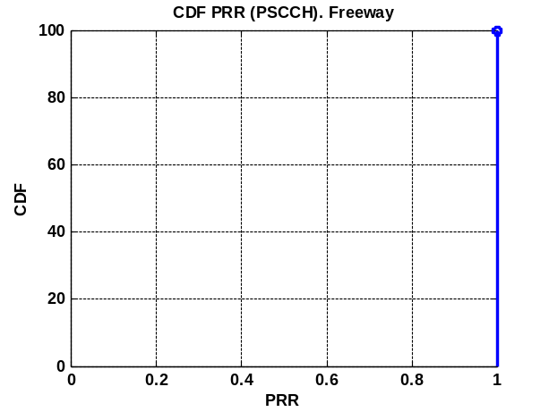  - PSCCH Freeway (320m) | 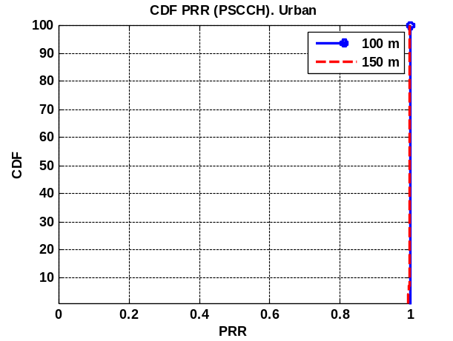  - PSCCH (100m / 150m)
Figure 2: PRR analysis for PSCCH (interference free environment)

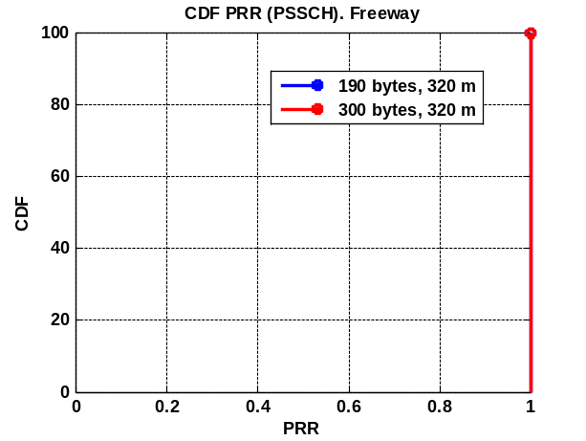  a) PSSCH Freeway (320m) | 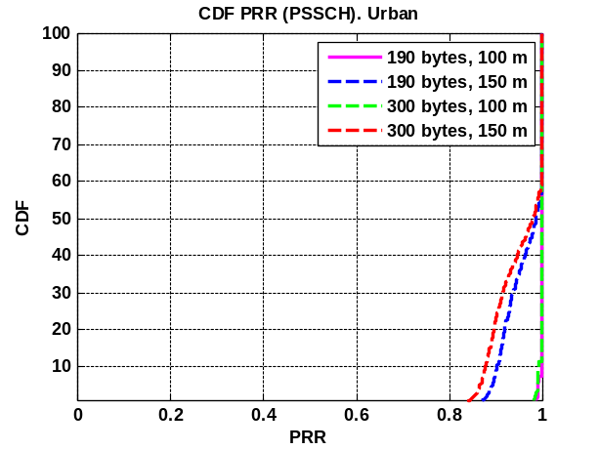  - PSSCH (100m / 150m)
Figure 3: PRR analysis for PSSCH (interference free environment)
Based on the presented above PRR analysis, we have the following set of observations:

Observation 2
- The considered freeway scenario does not have link budget limitations for the agreed target range (equal to 320m).
- In the Urban scenario:
  - Slight link budget limitation is observed in PSSCH for the target range of 150 m.
  - There is no link budget limitation in PSSCH for the target range equal to 100 m.
The link budget limitation that is observed in the Urban scenario for 150m range can be explained by several factors. First of all, the selected target range of 150 m is very large and exceeds the current 50 m requirement defined for vehicular Urban intersection scenario [3], which is in fact studied by RAN1 WG. In addition, according to our analysis RAN1 uses pessimistic assumption on 3 dBi vehicular antenna gain in azimuth while the practical antennas installed in vehicles may have higher antenna gain (e.g. 8 dBi). Therefore, we have the following proposals:
Proposal 1
- Discuss how to handle link budget limitations for 150m range in case of the Urban intersection scenario.
- Consider the following options for future studies and design work:
  - Increase antenna gain to 6 dBi;
  - Reduce target range to 100m for the Urban intersection scenario.

Performance Evaluation
As it was reported in [4], the LTE Rel.12 design is not sufficiently optimized in terms of PSSCH T-RPT allocation that may have an impact on low rate periodic traffic, due to buffering effects on inter-SCI period. Given the fact that MAC PDU is transmitted over 4 consecutive TTIs within T-RPT subframes, the certain UE implementations may result in a more intensified transmissions at the beginning of the SCI period while keeping PSSCH subframes at the end of the SCI period underutilized. Alternatively, the UE may skip some of the transmission opportunities within T-RPT subject to multiple of 4 TTI allocation constraint. In figure below, we provide performance of the discussed above transmission options (strategies) for freeway and urban scenarios, separately analyzing control channel (PSCCH) and overall (PSCCH+PSSCH) performance. In particular, we study the following resource allocation options:
- PSCCH/PSSCH 8 SFs/32 SFs; 15 kHz; 40ms period; T-RPT Baseline (N = 8, k = 2, 4; w/o random start time); QPSK; 12 PRBs (190 bytes) / 24 PRBs (300 bytes); 4 TTIs;
- PSCCH/PSSCH 8 SFs/32 SFs; 15 kHz; 40ms period; T-RPT Baseline (N = 8, k = 2, 4; w/o random start time); 16QAM; 12 PRBs (190 bytes) / 24 PRBs (300 bytes); 4 TTIs;
- PSCCH/PSSCH 8 SFs/32 SFs; 15 kHz; 40ms period; T-RPT Baseline (N = 8, k = 2, 4; random start time); QPSK; 12 PRBs (190 bytes) / 24 PRBs (300 bytes); 4 TTIs;
- PSCCH/PSSCH 8 SFs/32 SFs; 15 kHz; 40ms period; T-RPT Baseline (N = 8, k = 2, 4; random start time); 16QAM; 12 PRBs (190 bytes) / 24 PRBs (300 bytes); 4 TTIs.
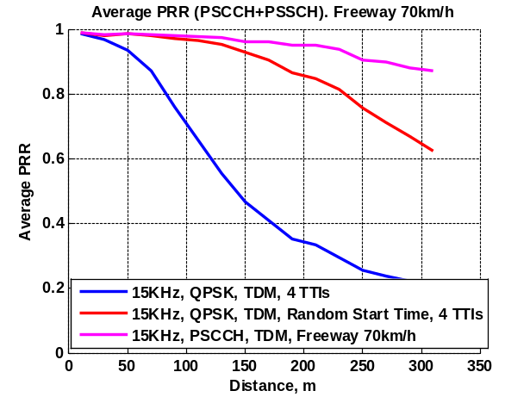  Freeway, 70 km/h – dense scenario | 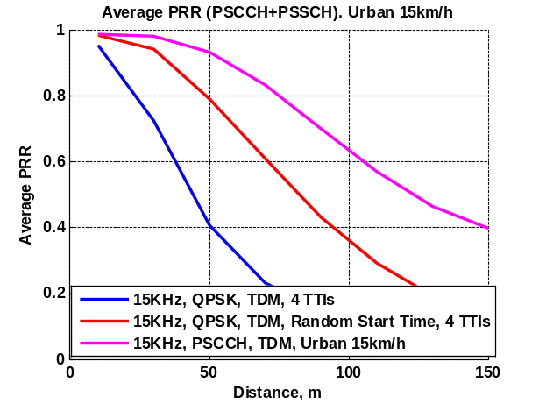  Urban, 15 km/h – dense scenario
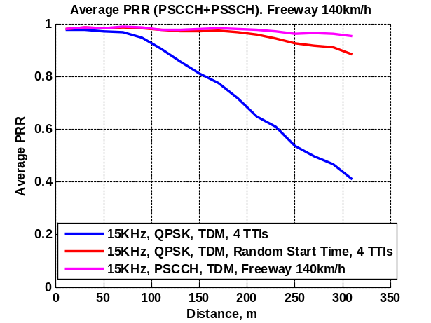  Freeway, 140 km/h – sparse scenario | 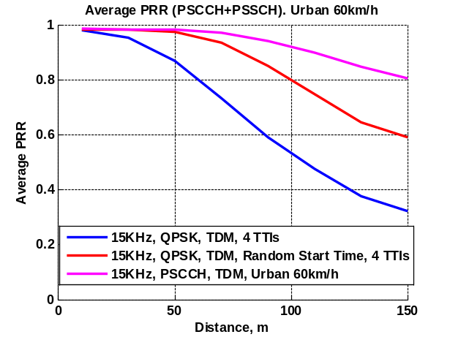  Urban, 60 km/h – sparse scenario
Figure 4: Evaluation of Rel.12 sidelink performance (Average PRR)
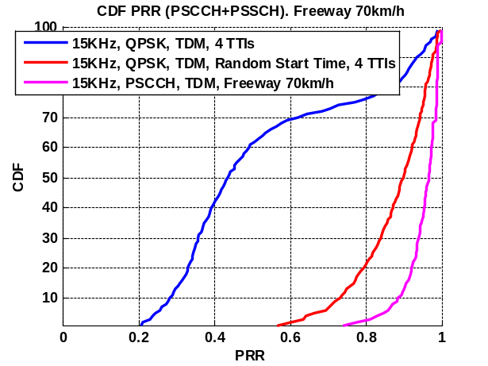  Freeway, 70 km/h – dense scenario | 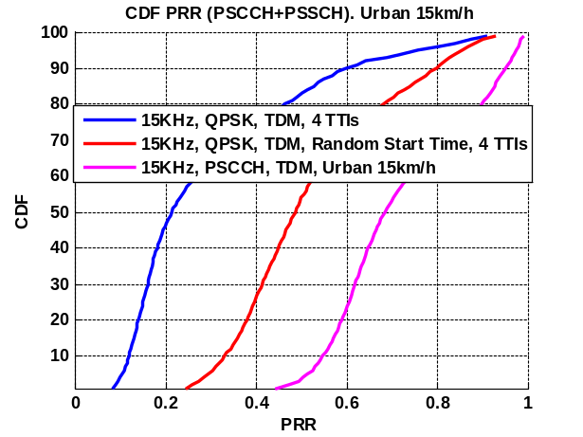  Urban, 15 km/h – dense scenario
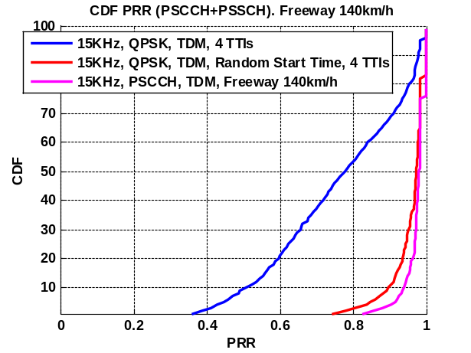  Freeway, 140 km/h – sparse scenario | 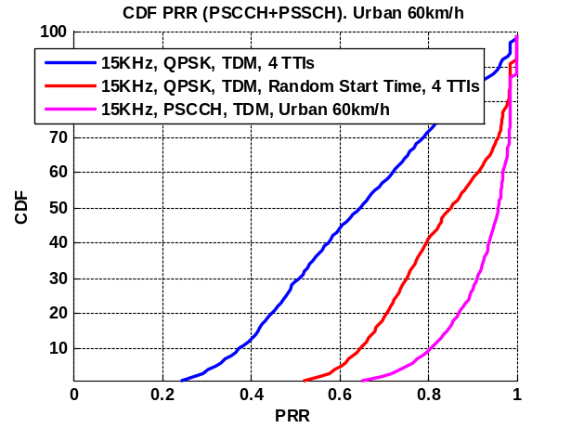  Urban, 60 km/h – sparse scenario
Figure 5: Evaluation of Rel.12 sidelink performance (PRR CDF)

Based on the presented above analysis, we have the following set of observations:
Observation 3
- The UE transmission behavior has significant impact on overall V2V communication performance.
- The transmission with random time offset within T-RPT should be considered as a baseline option.
- Significant interference issues (co-channel and in-band emission) are observed in dense Freeway 70 km/h and Urban 15 km/h scenarios.
- The Rel.12 performance is limited by PSSCH channel. The PSCCH consistently shows better performance.
- Additional enhancements of the Rel.12 sidelink communication should be considered to improve V2V communication performance.
Proposal 2
- RAN1 to evaluate baseline sidelink performance for benchmarking with new V2V design proposals.
Proposal 3
- The resource allocation option, where UE randomly selects the transmission time within a selected T-RPT pattern is considered as a baseline/reference Rel.12 UE behavior.

Conclusions
In this contribution, we provided system level studies of V2V performance in dense and sparse freeway and urban scenarios based on Rel.12 sidelink communication framework. Our analysis shows that it is desirable to further enhance current design of Mode-2 resource allocation for V2V services and additional enhancements of resource allocation and resource selection should be studied. Based on the presented analysis, we have the following proposal.
Proposals
- Discuss baseline configuration and default UE transmission behavior for benchmarking with Rel.12 sidelink design.
- Capture presented system level evaluation results and observations in the 3GPP TR.
- Analyze incremental gains of different design options relative to the Rel.12 sidelink design.

References
- RP-151109, “New SI proposal: Feasibility Study on LTE-based V2X Services”; LG Electronics, CATT, Vodafone, Huawei; Malmö, Sweden, June 15 - 18, 2015.
- R1-154981, “Updated offline discussion summary on V2X evaluation assumptions”; LGE; Beijing, China; August 2015.
- 3GPP TR 22.885 V1.0.0(2015-09), “Study on LTE Support for V2X Services (Release 14)”
- R1-144655, “On Remaining Aspects of D2D TX Behavior”, Intel Corp., Nov. 2014
- R1-156688, “On support of geo-based transmission for V2V communication”, Intel Corp., Nov. 2015
- R1-156535, “On benefits of adjusted LTE numerology for V2V communication”, Intel Corp., Nov. 2015
- R1-156690, “On enhancements to resource pool configuration for V2V communication”, Intel Corp., Nov. 2015
- R1-156536, “System level analysis of V2V design options in Freeway scenario”, Intel Corp., Nov. 2015
- R1-156537, “System level analysis of V2V design options in Urban scenario”, Intel Corp., Nov. 2015
- R1-156689, “Discussion on network control aspects for V2V communication”, Intel Corp., Nov. 2015
- R1-156538, “Demodulation analysis for V2V communication”, Intel Corp., Nov. 2015
- R1-156539, “Synchronization aspects for V2V/V2X communication”, Intel Corp., Nov. 2015

Appendix A: System Level Evaluation Assumptions
In this section, we provide summary of system level simulation assumptions used for V2V evaluation in this document.
Table 1: Summary of system level evaluation assumptions
Parameter | Value
Deployment Scenarios | Freeway road:  Dense: average inter-vehicular distance = 2.5 sec * absolute vehicle speed 70km/h  Sparse: average inter-vehicular distance = 2.5 sec * absolute vehicle speed 140 km/h  Urban:  Dense: average inter-vehicular distance = 2.5 sec * absolute vehicle speed 15kmph  Sparse: average inter-vehicular distance = 2.5 sec * absolute vehicle speed 60 km/h
Channel model | According to the agreed evaluation methodology in [2]
Traffic model | Periodic traffic model according to [2] with randomized initial arrival time  - 190 bytes every 100ms (four consecutive packets)  - 300 bytes every 500ms (every 5th packet)
Bandwidth | 10 MHz / 50 PRBs for PSCCH and PSSCH
Modulation and Transport Block Size | - Packet size - 190 bytes  - QPSK: 12 PRBs (code rate ~ 0.58 per TTI), TBS 1672, MCS 8  - 16QAM: 6 PRBs (code rate ~ 0.54 per TTI), TBS 1544, MCS 14  - Packet size - 300 bytes  - QPSK: 24 PRBs (code rate ~ 0.43 per TTI) , TBS 2472, MCS 6  - 16QAM: 12 PRBs (code rate ~ 0.42 per TTI), TBS 2408, MCS 12
Evaluation modes | Co-channel interference + in-band emission + half-duplex are taken into account  PSCCH & PSSCH;
Number of TTI per PDU | 4 TTIs (baseline)
PHY Abstraction | TBCC for PSCCH and CTC for PSSCH
# DMRSs per subframe | 15 kHz: 4 DMRSs for improved demodulation
Frequency hopping | Enabled

